St. Mary’s P.S and Cill Chluana Parish Nursery | 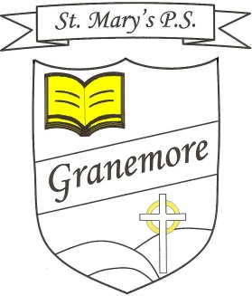  Learning through faith, laughter and love. | 123 Granemore Road  Tassagh  Co Armagh  BT20 2NJ
Principal: Mrs B Casey  bcasey632@c2kni.net |  | Telephone: 02837538018  Facsimile : 028 37538018

Dear Parent/Guardian, 11-02-2022

RE: Afterschool Clubs
We are delighted to be able to offer a number of afterschool clubs for the remainder of this term. We will be running the following clubs the week beginning Monday 21st February and will run for 7 weeks to the week of Monday 4th April.
Day | Class | Activity
Monday  Irish Dancing (All) | P1-P3 (All) | Irish Dancing (2-3pm)
 | P4-P7 (All) | Irish Dancing (3-4pm)
Tuesday  Gymnastics (Girls) | P2-P3 (Girls) | Gymnastics (2-3pm)
 | P4-P5 (Girls) | Gymnastics (3-4pm)
Wednesday  Gaelic (Boys) | P2-P3 (Boys) | Gaelic Football (2-3pm)
 | P4-P5 (Boys) | Gaelic Football (3-4pm)
Thursday  Drama (All)  **No club 17th March | P1-P3 (All) | Drama (2-3pm)
 | P4-P7 (All) | Drama (3-4pm)

Club | Duration | Cost | Payment
Irish Dancing | 7 Weeks | £24.40 | In a marked envelope directly to Mrs L Scallon.
Gymnastics | 7 Weeks | £28 | School App
Gaelic Football | 7 Weeks | £21 | School App
Drama | 6 Weeks | £18 | School App
Please note that spaces for clubs are limited due to staffing and facilities. However, places will be offered to other classes in the event where club numbers are available. Priority in term 3 will be given to classes/groups omitted on the above schedule.

Yours Sincerely
Mr. M. Murray

Please complete the permission slip below:

I give permission for my child _______________________________________

to attend the ___________________ afterschool club.
Signed: ___________________________________________________________________

