Raffle Prizes
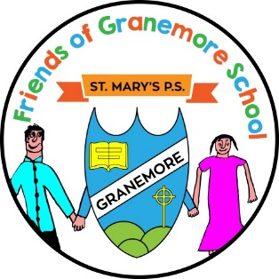
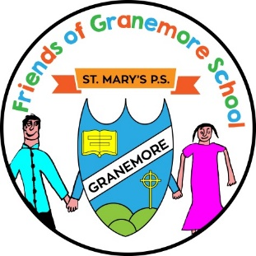
Large Food Hamper
Sponsored by Lappin’s Shop

Restyle
Sponsored by Lee Jentz Armagh

£50 One for All Voucher
Sponsored by Seamus Nugent Plastering

Video Camera Doorbell
Sponsored by Nugent Electrical

3 GAA Footballs
Sponsored by Sponsored by Granemore GFC

Hotel Chocolat: Merry Little Christmas Collection Hamper
Party 12 Case of wine
Sponsored by CircetNI

£50 Fuel Voucher
Sponsored by Proglass Autoglazing

Large Sweet Hamper
Donated by Suzanne McQuade

Large Ladies Gift Hamper
Donated by Hugh & Elaine Nugent

Large Box of Assorted Yankee Candles
Donated by Martin & Emer King

Large Christmas Aynsley Ornament
Donated by Deborah Regan
£30 Ardmedia Voucher
Donated by Arlene Nugent

£20 Derrynew Sports Recovery
Donated by Kevin & Teresa Murray

£150 Fuel Voucher
Donated by Aidan McClelland

Table Candle from Alexanders Markethill
Tin of biscuits
Box of chutneys
Donated by Anne-Louise Brennan

2 Large boxes of Dairy Box
2 Selection Boxes
1 Roald Dahl book
Donated by Colleen & Ben Firth

3 Sweet Jars
Donated by Mr & Mrs Firth

The Parent Support Group and all the staff of St. Mary’s Primary School wish to sincerely thank all of the businesses and parents that have contributed the wonderful and generous gifts above for our Christmas raffle.

