St. Mary’s P.S and Cill Chluana Parish Nursery | 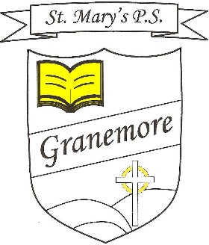  Learning through faith, laughter and love. | 123 Granemore Road  Tassagh  Co Armagh  BT60 2NJ
Principal: Mrs B Casey  bcasey632@c2kni.net |  | Telephone: 02837538018  Facsimile : 028 37538018

Friday 11th Sept 2020
Dear Parent,
We warmly welcome you to another school year and thank you for the support and commitment you gave to your child’s education during the lockdown period.
We have all settled into our new school year and the pupils have fully embraced the many new routines which have been put in place.
We will begin to set homework for your child next week and a detailed plan for each class can be found on Seesaw/Google classroom on Monday afternoon. We must adhere to DE guidelines regarding distribution and collection of pupil books and you will be asked to observe the homework routine which applies to your child.
Our pupils (from P4-P7) will complete a short tests next week in both Literacy and Numeracy, to provide us with a baseline for intervention and extension work in each class. P3 will complete the MIST test, which is normally administered in P2. These baseline tests replace our usual May standardised tests, for this year only. P6 pupils will take their annual CAT (Cognitive Ability Test) in the week beginning 24th September.
Our music services will resume towards the end of September for our P6 and P7 pupils, who were learning an instrument with the EA services prior to lockdown. Our P5 pupils will be offered the chance to avail of the services when the programme recommences. More details will be made available.
We have posted a school/parent/child agreement on our website and would urge you to familiarise yourself with its content.
Congratulations to our First Holy Communion and Confirmation children who received their sacraments last weekend. The pupils had many months to wait for their special occasion and we were very proud of how they conducted themselves. A special thank you to their class teachers, Mrs Kerr and Mr Murray and to Fr Greg, who made both occasions so personal and memorable for the children. Thank you also to our P6 parents, who financed the little gift bags for the P5 children and Mrs McGeary, who organised them.

Our pupils will continue to wear PE uniform for the next few weeks.
Please continue to wipe down lunchboxes and folders when they return home and before they come back into school.
Please see, on our school website, the link for applications for Free School Meals. We encourage you to apply, if you think you may be eligible. Every successful application has a very positive impact on our overall budget allocation.
Our amended holiday arrangements for this year have now been posted on the website. Please note that there are slight changes to Halloween and Christmas holidays.
We continue to urge you to keep your child at home, should they feel unwell. You are advised to seek a test should they present with any Covid symptoms, namely a cough, temperature and/or loss of smell or taste. (Please see separate letter from Dr Michael McBride on the website).
Remember to phone the school office if your child is not coming to school as we must record absences.
Thank you for your continued support.
Yours sincerely
Mrs Brenda Casey

