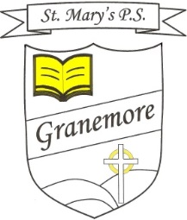

23-03-2020
Dear Parents
As you are aware, the Department of Education has asked that schools open this week to provide child minding for the children of key workers who may have no other option for childcare at present.
The ‘Derrynoose, Cill Chluana and Tynan’ Principals Group are keen to show our unreserved support for the ongoing challenge our healthcare services are currently facing. We realise we have a role to play in providing support for our communities.

Therefore, if you are a key worker and need to avail of child care provision, please get in contact with me, via email, bcasey632@c2kni.net by 2pm today( Monday) and state which days this week you may need your child to be in school.

At present, medical professionals advise that the safest place for your children is at home.
If children can stay safely at home, they should, to limit the chance of the virus spreading……schools remain open only for those children who absolutely need to attend.

I wish to thank you for the support and understanding you have shown during these extremely challenging times.
Any queries you may have in relation to your child’s learning can be emailed to the address above.

Stay safe everyone and remember to adhere to all guidance issued in relation to COVID 19 in the coming days, especially in relation to handwashing, social distancing and self-isolation.

Yours sincerely

Mrs Brenda Casey

