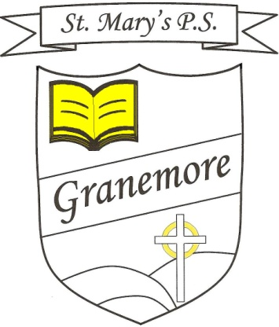**Monday’s Maths Challenge**

**Years 4 & 5**

**Teaching objectives**

Alesha bought a monster using only silver coins.

It cost her 45p.

There are nine different ways to pay 45p exactly

using only silver coins.

Find as many as you can.

**Monster**

**45**

**p**

Solve mathematical problems or puzzles.

Find totals.

Work out which coins to pay.

