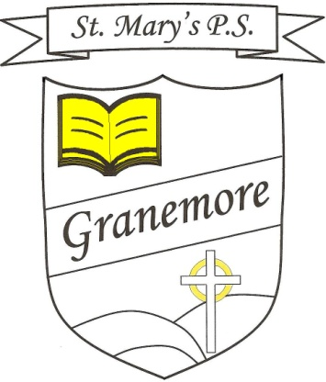**Monday’s Maths Challenge**

**Years 2 & 3**

**Teaching objectives**

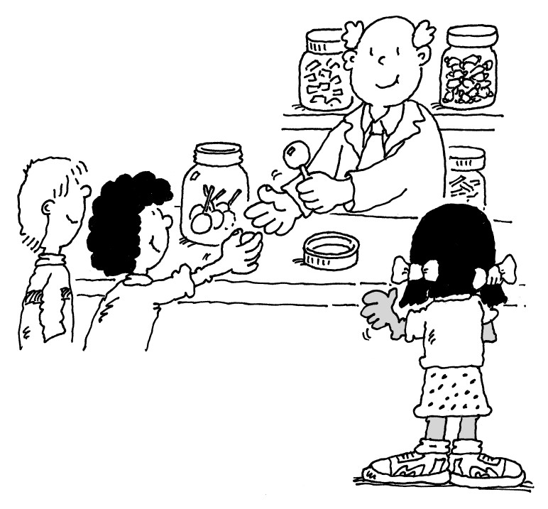

**Gob-stopper**

Jade bought a gob-stopper.

It cost 6p.

She paid for it exactly.

Which coins did she use?

There are 5 different ways to do it.

Find as many as you can.

What if the gob-stopper cost 7p?

Solve mathematical problems or puzzles.

Know addition and subtraction facts up to 10.

Find totals, give change, and work out which coins to pay.