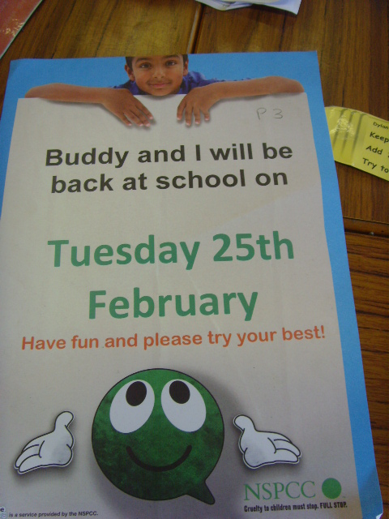 Childline

On Friday the 14th of February (St valentine’s day) St. Mary’s P.S. Got Sponsors for Childline P1-P4 did a sponsored Jumpathon while P5, 6 & 7 did a Spellathon and everyone enjoyed it. In P6 we had to find as many smaller words in “Today Is St. Valentine’s Day” and one of the girls found an astonishing 72.

In P1, 2, 3 & 4 there were big hoops and small hoops. That they had to jump into. One was for hopping, one was for jumping and one was for ski jumping sideways and jump over sticks. Then they had to land on a beanbag.
On Tuesday the 25th of February 2014. Angela, from NSPCC came into our school to give us our badges (Green, Bronze, Silver and Gold) that we earned by getting our sponsors for that week.
We are very happy and proud that we helped Childline & the NSPCC with child cruelty and can not wait until we help again next year.
We raised a whooping £2029.23 and this will help a awesome 507 children. P1 got a reward for the junior earning most money and P6 got the senior reward!

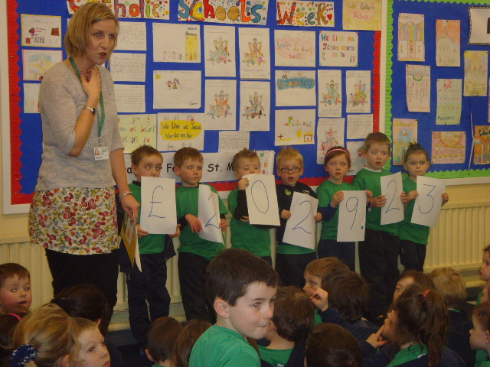By Michelle McGeown!

